Hassall Grove Public School | Student Use of Digital Devices  and Online Services Procedure
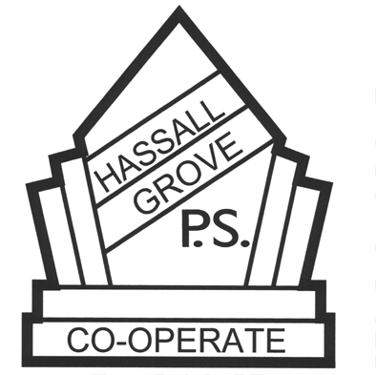

Purpose
This procedure guides student use of digital devices and online services at our school. Our school acknowledges the educational value of digital devices and online services in supporting and enhancing educational outcomes and student wellbeing. We also recognise they may cause harm if used inappropriately and that we need to support our students to use them in safe, responsible and respectful ways.

Scope
This procedure provides a consistent framework for the safe, responsible and respectful use of digital devices and online services by students in our school. It sets out the shared responsibilities of school staff, students and parents and carers. It also provides a framework to manage potential risks to student safety and wellbeing. This procedure covers student use of digital devices and online services in school-related settings, including on school grounds, at school-related activities and outside of school where there is a clear and close connection between the school and the conduct of students. This procedure covers the use of school-provided and personal digital devices and all online services.

Our School’s Approach
School devices are used to enhance the skills of the future-focussed learner and to support teaching and learning programs and curriculum adjustments. Home devices are handed in at the office for storage throughout the day.

Exemptions
An exemption from parts of this policy or the school procedure can be requested from the principal by parents, carers, school counsellors and other student support staff, and, if required, students themselves.

Consequences for inappropriate use
• The school will follow our behaviour management procedures
• The student may be referred to the Assistant Principal or Deputy Principal.

Contact between students and parents and carers during the school day
Should a student need to contact a parent or carer during the school day, they are to speak with the office staff. During school hours, parents/ carers are expected to contact the school office to pass on messages.

Responsibilities and obligations

For students
• Be respectful and follow school rules and procedures.
• Be safe, responsible and respectful users of digital devices and online services, and support their peers to be the same.
• Communicate respectfully and collaboratively with peers, school staff and the school community and behave in the ways described in the Behaviour Code for Students.

For parents and carers
• Recognise the role they play in educating their children and modelling the behaviours that underpin the safe, responsible and respectful use of digital devices and online services.
• Support implementation of the school procedure, including its approach to resolving issues.
• Take responsibility for their child’s use of digital devices and online services at home such as use of online services with age and content restrictions.

For the principal and teachers
• Deliver learning experiences that encourage safe, responsible and respectful use of digital devices and online services.
• Establishing agreed classroom expectations in line with this procedure and departmental policy.
• Respond to and report any breaches and incidents of inappropriate use of digital devices and online services.
• Model appropriate use of digital devices and online services in line with departmental policy.

For non-teaching staff, volunteers and contractors
• Be aware of the department’s policy, this procedure and act in line with the conduct described.
• Report any inappropriate use of digital devices and online services to the principal, school executive or school staff they are working with.

Communicating this procedure to the school community
Students:
• Classroom teachers will inform their students about this new procedure.
Parents and carers:
• This procedure can be accessed electronically via the school's website and in hardcopy at the school's administration office.

Complaints
If a student, parent or carer has a complaint under this procedure, they should first follow our school's complaints process. If the issue cannot be resolved, please refer to the Department's guide for making a complaint about our schools (https://education.nsw.gov.au/about-us/rights-and-accountability/complaints-compliments-and-suggestions).

Review
The principal or delegated staff will review this procedure annually.

