Framework for Learning from home (Week 1)
29th April– 1st May 2020
Hassall Grove Public School - Stage 2
Please do what you can. You may need help from a parent/carer.
 | Wednesday 29/4 | Thursday 30/4 | Friday 1/5
Morning | English  Journal writing – write and draw how you’re feeling today  Sentence observations. Change the font colour or place a box over the important parts of the sentence. Label the boxes.  My silly sister Samantha giggles a lot.  Read for 20 minutes.  Grammar – verbs.  Highlight or change the font colour of the verb in each sentence.  Change the underlined verbs to make them more interesting. | English  Journal writing – write and draw how you’re feeling today.  Sentence A Day  Add capital letters and full stops.  the fox was quick  Read for 20 minutes.  Word of the Week  sink – write out the definition. Create three sentences using the word of the week. | English  Journal writing – write and draw how you’re feeling today.  Sentence observations. Change the font colour or place a box over the important parts of the sentence. Label the boxes.  Sarah and Matthew are extremely competitive handball players.  Read for 20 minutes.  Grammar – verbs.  Fill in the correct past tense verbs.  Highlight the verbs.  Introduction to verb groups.  Word of the Week  Add 5 words with the –ink blend.
Break | Break | Break | Break
Mindful time | Listen to ‘A book of Mindfulness’ by Susan Verde on Epic Books. | Mindful breathing. | Write three things you are grateful for.
TENS | Cross Out | Cross Out | Cross Out
Middle | Mathematics  Year 3  Looking for number patterns in addition problems. These could be friends of ten, doubles, near doubles, one more and so on.  Year 4  Ascending and descending numbers. Look at a variety of numbers and place them in ascending and descending order. | Mathematics  Year 3  Solving word problems using Newman’s prompts.  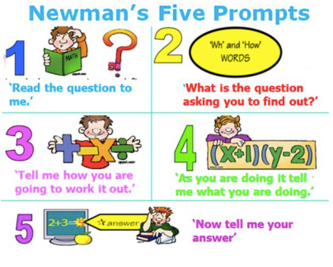  Year 4  Continuing and describing number patterns. | Mathematics  Year 3  Properties of 2D shapes.  Matching 2D shapes, identifying the number of edges and vertices.  Complete Mathletics activity.  Year 4  Multiplication  Complete Mathletics activity.  Roll two dice and multiply. How many can you solve in 10 minutes.  Multiplication algorithms.
Break | Break | Break | Break
Afternoon | History  How has our community changed over time?  Observe changes in photos of Circular Quay. What changes can you notice? What was Sydney like? Did anything stay the same?  Write a comment about your day in your Google Classroom. | Science  Find out what students know about how Earth’s rotation on its axis causes regular changes, including day and night. What do students think causes night and day.  Write a comment about your day in your Google Classroom. | Drama  Introduction of Drama unit: monologues. Students read the different monologues and select one which they will practice.  Write a comment about your day in your Google Classroom.

