How to Create a Picture Graph
A picture graph is created using pictures to represent data. In the following picture graph, the first column tells us the name of the fruit that people like, and the second column tell us how many children like the fruit. Each picture represents one person. If there are 7 pictures of pears, then it means that 7 children like pears and only 1 child likes each of the other fruit. Once the graph has been created, student’s will then need to answer the following questions. An example of each answer has been provided.
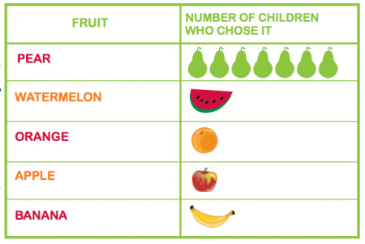
- Which fruit is the least favourite? Watermelon, orange, apple and banana
- How many people were asked altogether? 11 (you will need to count all the pictures to work out how many people were surveyed)
- How many more people liked the most popular fruit than the least popular fruit? The most popular fruit has 7 children liking it, the least favourite fruit has 1 child liking it. To work out the answer just do 7-1 which equals to 6
Fruit | Number of people who chose it

- Which fruit is the least favourite? ____________________________________________

- How many people were asked altogether? _____________________________________________

- How many more people liked the most popular fruit than the least favourite fruit? ____________________

